2018
Implementing Agency: Kheri Karmu Gram Panchayat

Technical Support: Consortium of India Water Partnership (IWP)
DRAFT DETAILED PROJECT REPORT

SOLID LIQUID WASTE MANAGEMENT

KHERI KARMU GRAM PANCHAYAT,
SHAMLI BLOCK, SHAMLI DISTRICT,
UTTAR PRADESH

Table of contents

1 Introduction 1
1.1 Methodologies followed for preparing DPR 1
2 Assessment of Existing SLWM Systems 2
2.1 Existing Solid Waste Management System 2
2.2 Existing Liquid Waste Management System 3
3 Proposed SLWM System 5
3.1 Salient Features of the Model 5
3.2 Proposed Solid Waste management System 5
3.3 Proposed Animal Waste management System 7
3.4 Proposed Liquid Waste Management System using Constructed Wetlands 8
3.5 Proposed Institutional Structure 9
3.6 Proposed Awareness Campaigns 10
4 Investment Requirements and Phasing 11
4.1 Capital Expenditure 11
4.2 Investment of SLWM system in Kheri Karmu GP 12
4.3 Operation & Management (O&M) Costs 12
5 Sustainability and Implementation of the Project 13
5.1 Physical Sustainability 13
5.2 Financial Sustainability 15
5.3 Implementation Plan 15
Annexure 17
Annexure 1: Letter from Panchayati Raj Department, GoUP 18
Annexure 2: Methodologies followed for preparing the DPR 20
Annexure3: Reed-Bed Technology or Root Zone Technology 25
Annexure 4: Financial Details of Reed-Bed Filter 29

List of Exhibits
Exhibit 1: Methodologies followed for preparing DPR 1
Exhibit 2: Existing Solid Waste Management System in Kheri Karmu Gram Panchayat 2
Exhibit 3: Existing Wastewater Management System in KHERI KARMU Gram Panchayat 3
Exhibit 4: Proposed Solid Waste Management system for Kheri Karmu Gram Panchayat 6
Exhibit 5: Key specifications of the Resource Recovery Centre (RRC) 7
Exhibit 6: Layout Plan of Resource Recovery Centre for SWM for Kheri Karmu Gram Panchayat 7
Exhibit 7: Handling and management of Animal Waste 7
Exhibit 8: Proposed Liquid Waste Management system for Kheri Karmu Gram Panchayat 8
Exhibit 9: Area Map (not to scale) – Kheri Karmu Village 9
Exhibit 10: Proposed Institutional Structure for proposed SLWM system 9
Exhibit 11: Capital Expenditure for the entire SLWM for Kheri Karmu Gram Panchayat 11
Exhibit 12: Operation and Maintenance Cost 12
Exhibit 13: Revenue Generation methods 15
Exhibit 14: Steps to be followed to implement the Plan 15

List of Abbreviations

BDO | Block Development Officer
BOD | Biological Oxygen Demand
COD | Chemical Oxygen Demand
CW | Constructed Wetlands
CSR | Corporate Social Responsibility
DPR | Detailed Project Report
DWSC | District Water and Sanitation Committee
FGD | Focused Group Discussions
GOI | Government of India
GP | Gram Panchayat
HH | Households
IEC | Information Education and Communication
IWP | India Water partnership
MDWS | Ministry of Drinking Water and Sanitation
NBA | Nirmal Bharat Abhiyan
NGO | Non-Government Organization
NGP | Nirmal Gram Puraskar
ODF | Open Defecation Free
PLA | Participatory Learning and Action
PRA  PRD | Participatory Rural Appraisal  Panchayati Raj Department
RRC | Resource Recovery Centre
SBM | Swachh Bharat Mission
SLWM | Solid and Liquid Waste Management
TSC | Total Sanitation Campaign
VWSC | Village Water and Sanitation Committee

Introduction

Swachh Bharat Abhiyan (Gramin) (SBM-G) was launched in October 2014 with an objective to bring about improvement in the cleanliness, hygiene and the general quality of life in rural areas. Solid and Liquid Waste Management (SLWM) is one of the key components of the programme.

India Water Partnership (IWP) has agreed to extend technical support to the Panchayati Raj Department (PRD), Government of Uttar Pradesh (GoUP) to develop model Gram Panchayats that showcases replicable models of Solid and Liquid Waste Management. IWP will support the Gram Panchayat in preparing the Detailed Project Report (DPR) for SLWM system (Letter from PRD is attached as Annex-1).

Key Indicators of Kheri Karmu Gram panchayat
No. of Villages: 2 (Kheri Karmu and Shamli Rural)
Kheri Karmu | Shamli Rural
Total HHs: 1609 (MDWS)  Distance from Sub-District HQ Shamli: 5kms | Total HHs: 22 (MDWS)  Distance from Sub-District HQ Shamli: 0.5kms

Methodologies followed for preparing DPR

To understand and assess existing SLWM and to develop DPR, following activities were carried out:

Exhibit 1: Methodologies followed for preparing DPR
Activities |  | Stakeholders |  | Tasks
Orientation Workshop  (20th Dec 2017) |  | Pradhan, GP secretaries, DPRO, Local NGOs |  | - Project Introduction  - Discussion on future plans & stakeholders support
Transect Walk  (20th Dec 2017) |  | GP officials, Pradhan, Sarpanch, villagers (volunteers/ motivators) |  | - A quick walk around the village to understand existing systems and Identify problem areas
Consultations with Key Stakeholders  (18th Jan 2018) |  | GP officials, Local NGOs, select motivators |  | - Discussed existing systems  - Discussed past and current plans/ programmes, financial condition etc.
Participatory Rural Appraisal & Village Mapping  (18th Jan 2018) |  | GP officials and Villagers |  | - Discussion on existing condition and aspirations for SLWM  - Preparation of village/resource map in discussion with villagers
Suggestions on DPR  (19th Jan 2018) |  | GP officials and Villagers |  | - The proposed model shared with villagers  - Valuable suggestions and comments received and further incorporated
Final Discussion in Gram Sabha  (19th Jan 2018) |  | GP officials and Gram Sabha |  | - The final DPR shared with villagers and approval from the Gram Sabha on SLWM DPR

All the tasks and discussions carried out for preparation of DPR as discussed in Exhibit-1 have been detailed out in Annex-2.

Assessment of Existing SLWM Systems

Existing Solid Waste Management System

At present, there is no collection and disposal mechanism. Exhibit 2 below outlines the current waste generation and the present methods used for disposing off the solid waste. The Kheri Karmu Gram Panchayat does not have any infrastructure to collect and transport the solid waste and there is no specified location for the solid waste disposal.

Exhibit 2: Existing Solid Waste Management System in Kheri Karmu Gram Panchayat

Waste Generation |  | Collection and Transportation |  | Disposal
Total estimated Solid Waste generated:  - 600 gms per HH per day*  Types of Solid Waste:  - Bio-degradable: Animal waste, vegetable waste  - Non-Bio-degradable: Plastic bags, papers, glass  Solid Waste Sources:  - HH, Schools/ Anganwadis, Shops etc. |  | - Currently there is no scientific system to daily collect and/or transport the solid waste generated  - Once in 2 to 3 months, solid waste is collected from roads/drains and transported to an open area outside the village. |  | Current Disposal methods:  - Animal Waste: Individual compost pit at home or field. Waste is piled & left open outside houses to be used as manure in 6 month  - Vegetable & food waste: Given to livestock, reused in garden/ field  - Plastics: thrown outside, in open area, fields, drains or burnt (80% HHs)

In the absence of systematic solid waste handling methods, following issues are being faced:
- Accumulation of waste at open spaces, street sides/ drains, leading environmental degradation
- Absence of regular cleaning of drains/ roads, due to no permanent Safai-Karamcharis in the GP
- Most of the drains get blocked due to waste dumping and leading to overflowing of drains.

With respect to the solid waste generation and disposal, the following trends were observed and also discussed with the residents:

- There is no dustbin culture in the village. The residents throw their waste out on the street corners as and when they want and hence calculating the volume based on dustbins is not possible.
- There is no collection mechanism and hence volume analysis based on final dumping is also not possible.
- Organic waste especially food waste is usually not thrown instead fed to cattle at home by a majority of residents. Hence, calculating the organic waste output based on dustbins is again not possible.
- Hence, the volume considered has to be based on data available and local dynamics. The assumption hence is to consider only non-degradable items as the output and encourage the culture of not dumping food waste and use it as compost at homes and feed for cattle. The proper way to handle organic waste at source can be included as part of the awareness initiatives.

According to the data available with municipal corporations, the amount of solid waste generated per person per day may range in the values of 0.2 to 0.5 kilograms (Source: Pune Municipal Corporation and Chennai corporation data). Hence, an average value of 0.35 kg was considered. Out of the 0.35kg further assumption is made that around 0.15kg of organic waste is being used as a feed for cattle or dumped along with cow dung for composting. An average mean of 4 adults per house hold is considered which brings the figure to 0.15*4 = 0.6kg per household.

Existing Liquid Waste Management System

Liquid waste is one of the major issues plaguing the Gram Panchayats all across India. Absence of proper drainage mechanisms is a major contributor to lot of vector borne and water borne diseases. This can be seen as a common picture in all the Gram Panchayats. There were 2 distinct scenarios identified at Kheri Karmu Gram Panchayat at Shamli. In some streets, there are drainages of 1ft width and 1ft depth and in some of the streets the liquid waste flows directly on to the streets.

The Liquid waste from the streets and drainages flows in to the stream running parallel to the Gram Panchayat from 7 different locations. The water from the streets is directed to the stream via makeshift drain paths. The following points with regards to Liquid waste output from the gram panchayat are important

- The volume of water entering the stream cannot be determined at the end point accurately as the water flow is from different locations and is not defined.
- The distance between residential houses and the water stream is a maximum of 300ft in most of the areas. In other words, the houses are almost in the banks of the stream and the waste water flows in between houses. So, there is very limited space for any kind of treatments to be done at the exit points.
- The village is divided in to 2 parts. There are settlements on either side of the main road. Hence, a single system of waste water treatment for the entire village is not possible.

As per standards laid down by the CPHEEO (Central Public Health Environmental & Engineering Organisation), the fresh water consumption per day per person should be between 135 to 150 litres per day in urban settings and between 50 – 80 litres in a rural setting. It is officially expressed as “litres per capita daily” (lpcd). Since, accurate calculation of volume of waste water is difficult as explained above; an average of 60 litres per day per person is taken as the basis for calculation.

The eastern side of Kheri Karmu has around 1000 houses and the western side has around 609 houses (data from Gram Panchayat records). The eastern side hence will generate on average 2,40,000 litres per day (60litres*4 persons per household*1000 houses). An additional 20,000 litres is added as miscellaneous. The western side in the same lines of calculation will generate 1,50,000 litres. For the purpose and scope limited to this DPR the eastern side is taken as the implementation zone.

Exhibit 3: Existing Wastewater Management System in KHERI KARMU Gram Panchayat
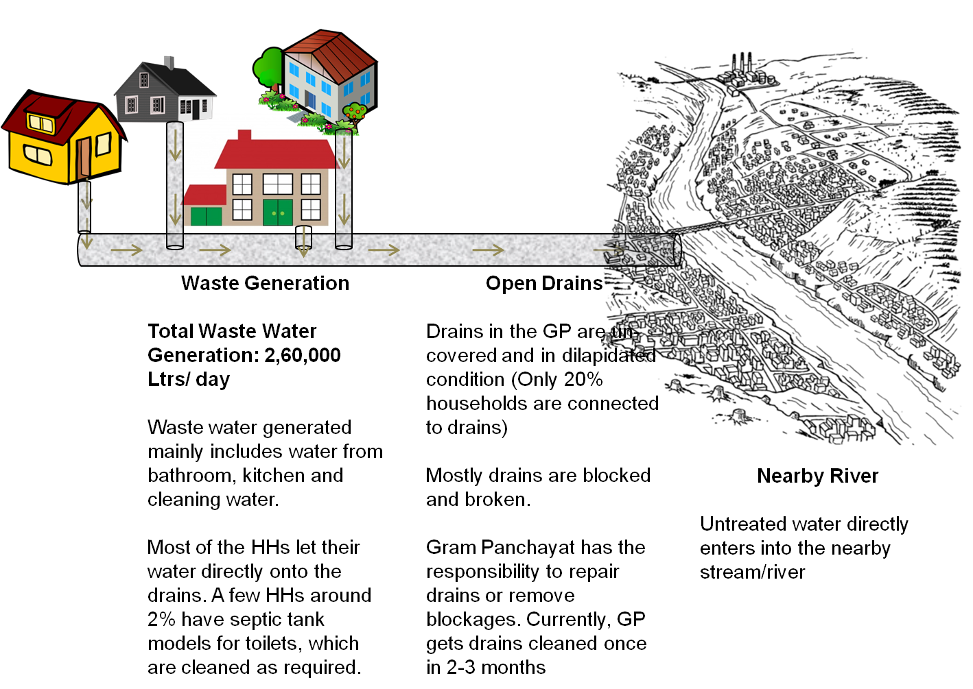

In the absence of systematic liquid waste handling methods, following issues are being faced:
- Open drains pose a serious health issue for the entire village. The waste water is stagnated in most of the areas and act as breeding spot for mosquitoes and other insects.
- As per the data from the Swatch Bharat Mission (SBM), the village has been declared as ODF. The transect walk along the entire GP gave a picture that most of the houses with toilets have a simple tank based system. Soak pits are not very popular in this area for reasons of not having space. There are still a few houses which directly pass the black water on to the streets.
- The waste water gets collected in the village ponds which is leading to its contamination and pose serious health issues for the entire village.
- The untreated water directly drains into the stream, thus polluting it.

The Kheri Karmu GP lacks the basic infrastructure across the whole value chain of SLWM. Thus, there is an urgent need to bring in the improved, efficient and sustainable SLWM system for clean and green GP as well as there is need to connect all the houses to the waste water management system.

Proposed SLWM System

The solutions have been proposed based on the inputs given by the Gram Panchayat and the baseline survey findings and existing situation assessment.

Salient Features of the Model

- Complete thrust on awareness and behaviour change
- Basic infrastructure to aid and sustain the behaviour change envisaged
- Systematically collect & transport segregated solid waste with dedicated service delivery team
- Complete community and Gram Panchayat ownership to execute, manage, monitor, evaluate proposed SLWM system
- Complete transparency and accountability with management & reporting system and having a dedicated monitoring committee consisting mainly of local villagers
- Self-sustainability of operation and maintenance is ensured with the help of user fee collection and waste by-products. The monthly expenditure for the project can be met from the user fee collection itself if it is made mandatory and everybody adheres to it from the first month itself(Gram Sabha collectively endorsed the proposal to collect user charges of Rs. 20 per HH per month). Keeping in mind the practical constraints to collect user charges from the project commencement, the maintenance support should be given as a part of SLWM budget.

Proposed Solid Waste management System

The Solid Resource Management is divided in to 5 stages:
- Generation of waste
- Responsible disposal of waste
- Timely collection of waste
- Segregated transportation of waste
- Scientific processing of waste with area consideration

The system that is described above works on all the 5 stages with different approaches. A successful waste management program should have an integrated approach covering all these aspects and a strong monitoring system in all these phases has to be set up to ensure sustainability of the project

Generation of waste
The critical factor in any waste management system is the amount or volume of waste that is generated. The processing capacity and technology depends on this factor. On the flip side, it is also equally important to ensure that the people are made aware of their responsibility towards the environment. The most basic being their understanding of the term garbage and their role in ensuring that they reduce the waste that is generated by them. This has to be the core message that should be delivered to the people in the area no matter how sophisticated the system of processing is. Minimal usage of plastics, no usage of non-recyclable plastics and segregation are key messages that should be passed on to the residents in the area.

Responsible disposal of waste
Disposal of waste is the one factor that contributes to the unhygienic conditions prevalent in our country. The habit of disposing of waste in a hygienic manner is very poor in our country. This is partly due to the mindset of the people and partly due to unavailability of uniform and easy to access disposal facilities. This is addressed in the proposed integrated system by way of providing disposal utilities in the form of dustbins to each household as well as on the streets. The residents will be motivated as they can now feel the intensity in the program and a complete cooperation can be demanded once utilities are provided to them. This will obviously boost the desired source segregation of waste which extremely crucial in the processing of waste irrespective of technology.

Timely Collection of Waste
Waste is not waste if it is collected within 12 hours of generation. It is termed as a resource. After 12 hours, the microorganisms start settling in the garbage and produce foul smell which will be very difficult to handle. Hence, systematic and timely collection of waste is extremely essential for successful processing and conversion into resource. The workers will have scheduled timings for collection of waste in a decentralized manner with proper documentation. This ensures that the households are also catered positively and there is scope of grievance redressal also. The workers should have a time schedule with dedicated area which will be reviewed by the supervisors on a weekly basis.

Segregated Transportation of Waste
Decentralized collection is a very crucial aspect and similarly decentralized segregated transportation is also important. The effort put in by the people has to be complimented with systematic and timely transportation of the waste collected in the same segregated manner. This can be ensured by having segregated compartments in the collection vehicles and by having enough number of vehicles plying regularly on scheduled timings ensuring the waste is transported to the processing area immediately after collection.

Processing of Waste
This is the final phase of the waste management where waste is converted in to some form of a resource. This could be using composters to convert the waste collected in to compost or generating bio-gas from the waste or even conversion in to electricity. All this depends on the volume and the characteristics of waste collected. The better the segregation is at source, the better chances of sophisticated processing. This is the golden rule of Integrated Solid and Liquid Resource Management.

The key components of the proposed SWM system are shown in Exhibit-4 below:

Exhibit 4: Proposed Solid Waste Management system for Kheri Karmu Gram Panchayat
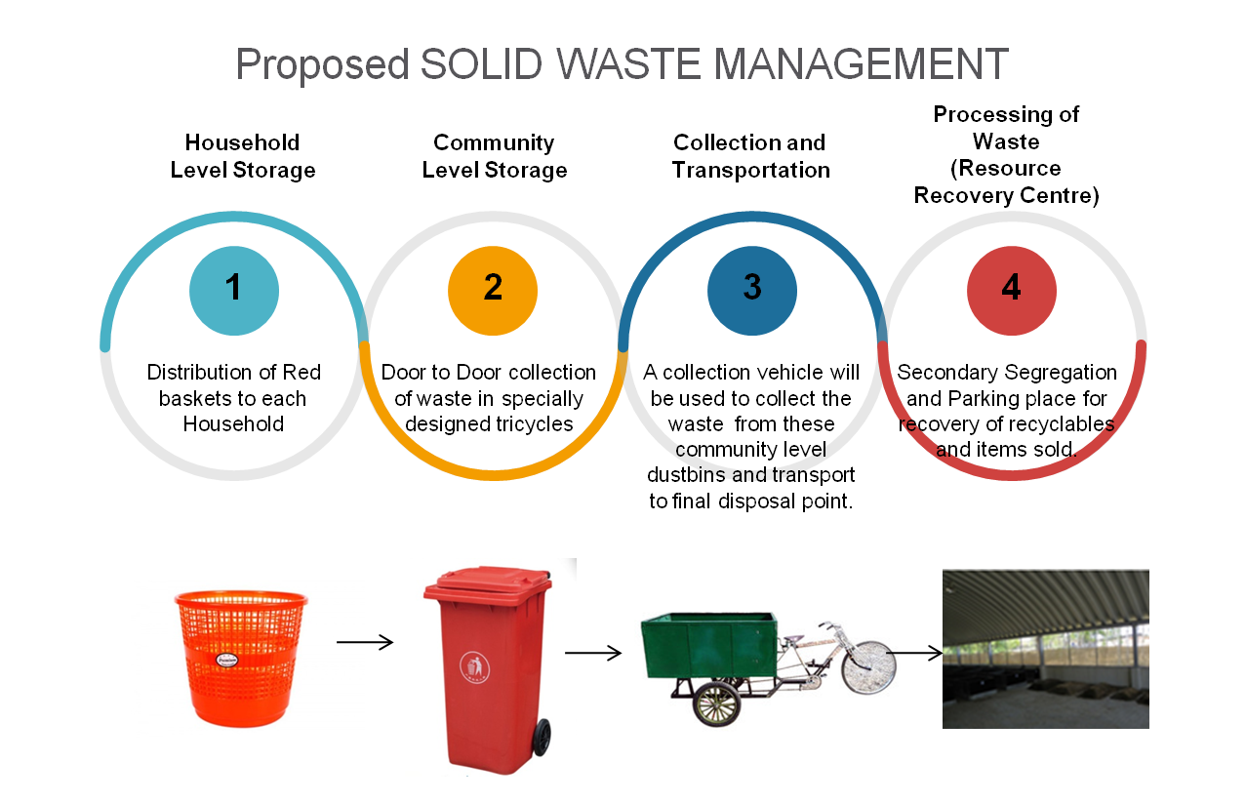
Note: The photos and diagrams of the components shown are just basic representation of the original components to be provided in the Gram Panchayat

The exhibit above covers all the stages in Solid waste management in accordance with the situation at the Gram Panchayat. Generation, collection and transportation, processing is shown pictorially in the exhibit above.

In order, to bring the dustbin culture in the village it is suggested to give one dustbin (Red or Blue) for depositing only the non-degradable waste from the houses. Common dustbins will also be placed to ensure that the household deposits their waste if the dustbins get filled up before the collection time.
Door to door collection as well as emptying of common dustbins will be carried out using push cart cycles on a daily basis. These will be taken to the Resource Recovery Centre (RRC) for immediate segregation based on value and packed for selling.

Exhibit 5: Key specifications of the Resource Recovery Centre (RRC)
Description | Volume
Total Building Area | 300 sq feet  (Side walls made of Iron rods and mesh)  (G.I. Sheet for roof)
Height Of The Building | 12 Ft
Waste Handling Capacity | 750 kgs /day

Exhibit 6: Layout Plan of Resource Recovery Centre for SWM for Kheri Karmu Gram Panchayat

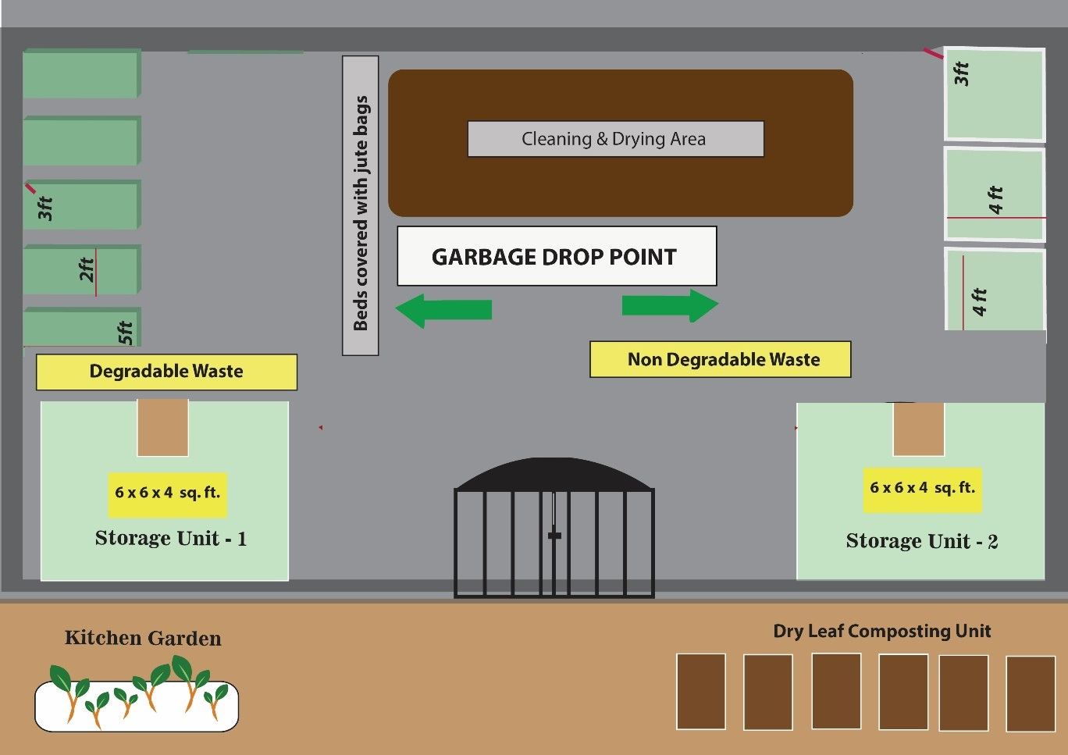

Proposed Animal Waste management System

In addition to the household solid waste, the animal waste (mostly cow dung) is present in large amount, however, it is considered as a resource by the rural community and hence reluctance on part of the community to share and/or dispose along with the proposed solid waste system. Hence, it is proposed to undertake structured awareness campaigns to suggest proper and effective handling and process of composting of cow dung, as described in Exhibit-7 below, with an objective to have reduced odour and increased effective composting to produce rich manure.

Exhibit 7: Handling and management of Animal Waste
- Identify and select location, preferably within HHS, where 3-4 feet square pile can be built
- Spread 3-inch dry organic material layer on the area, then spread 2 inch of manure on top
- Continue layering till 4 feet tall pile, and ensure watering as it is built to keep it slight damp
- Finally cover it with a layer of soil
- Turn the pile every 4 days, while keeping the pile moist but not soggy
- Use the compost when it is dark brown, crumbly, and has an earthy smell

Proposed Liquid Waste Management System using Constructed Wetlands
The proposed liquid waste management system is outlined in Exhibit-8 below:

Exhibit 8: Proposed Liquid Waste Management system for Kheri Karmu Gram Panchayat
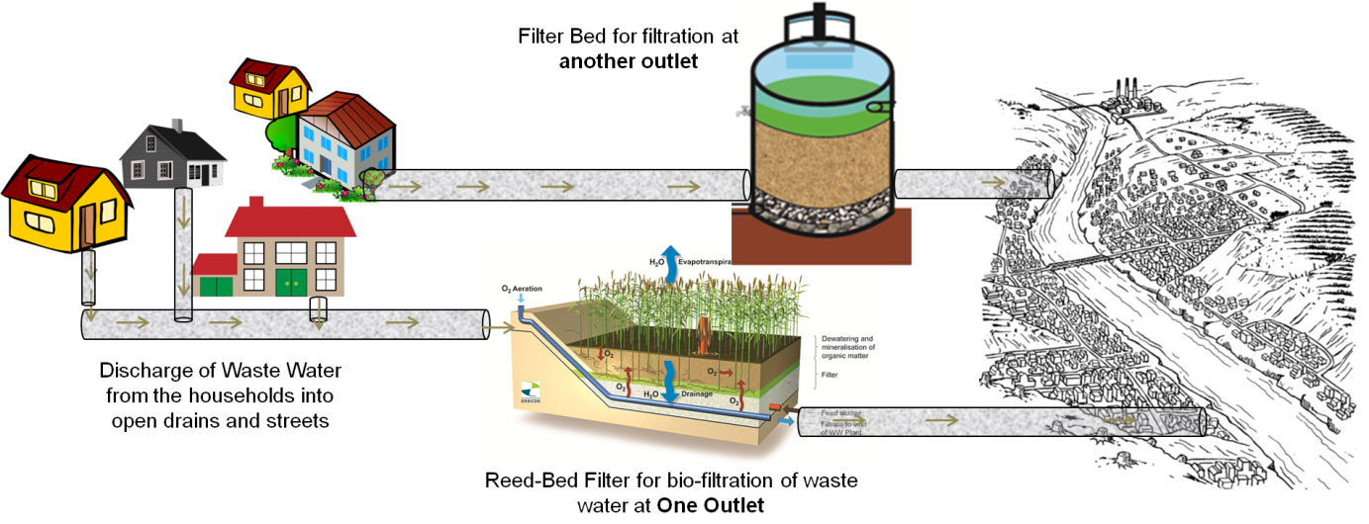
Note: Detailed structure of Reed Bed Filter is presented in Annex-3.

Key considerations while proposing the new liquid waste management system in Kheri Karmu GP:
- Individual soak pits in each HH is not feasible due to space constraints. HHs having no access to drainage system will have soak pits as an alternative, wherever possible.
- The entire system of routing the waste water to one common point is already present and hence continuing the same will be a cost-effective solution. However, the existing drainages need to be deepened and improved to increase their carrying capacity.
- A pre-filter chamber will be constructed to address the shock loads of water, before the water enters the filtration chamber.
- Reed-bed filter will be implemented for bio-filtration of waste water, before the water enters the stream. Annex-3 explains the Reed bed filter and advantages of bio-filtration.
- The waste water collected and filtered can also be used as a water source for the agriculture purposes. This practice can be promoted in the Gram Panchayat through different awareness activities.

Exhibit 9: Area Map (not to scale) – Kheri Karmu Village
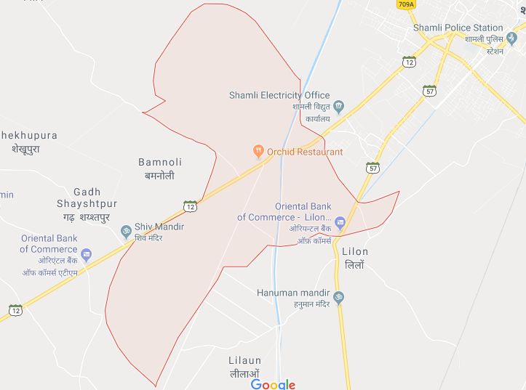

Proposed Institutional Structure

Accountability, Monitoring and sustainability of the initiatives are of extreme importance in order to sustain the activities initiated as part of the SLWM. For this purpose, Exhibit-10 outlines the proposed institutional structure for sustainability of the proposed SLWM system:

Exhibit 10: Proposed Institutional Structure for proposed SLWM system
Gram Panchayat |  | All Members of the Gram panchayat  The overall responsibility to oversee the service and assets
Village Water and sanitation Committee |  | Already existing members  The existing committee will provide the guidance to the SLWM committee and will act as the liason between the panchayat and the district.
Solid and Liquid Resource Management Committee |  | Sarpanch, Gram Sevak and few ward members or representatives (natural leaders), members from the NIGRANI committee, one member from service delivery team.  It will monitor the service delivery team on a daily basis and provide support and guidance on day to day operations
Service Delivery Team |  | 1 Supervisor and 3 Safai-Karamcharis  They will collect, transport, dispose of solid waste daily  Maintenance of drains &periodical clean of filter bed/ chamber

The Nigrani committee that has been set up in the GP to oversee the ODF activities and sustain those activities will be integrated in to the SLWM committee. They will play the role of monitoring the SLWM project as well as work towards sustaining ODF status of the gram panchayat.

Service Delivery Team is the most important part of the structure as it has to run the whole system on the daily basis. The service delivery team will have specific responsibilities. Few of those are:
- Every day collection of waste from the common dustbins and maintenance of the dustbins, transportation of the waste collected to the resource recovery centre and its maintenance;
- Daily segregation and packing of non-degradable items
- Maintenance of the drains and periodical cleaning of filter bed and chamber
- Maintenance of all accountability registers & reporting on a daily basis to the SLWM committee

Additionally, service delivery team will offer certain value added on call services. Few of them are:
- Setting up Animal Waste compost beds (execution or training)
- Individual soak pit construction (where needed especially for black water)
- Sale of sanitation related products (6 months after the initiation of project based on demand)

Besides these responsibilities to maintain transparency, the attendance registers, collection registers, volume registers, sales registers and feedback/ suggestion register will be maintained.

Proposed Awareness Campaigns

In order to sensitize the villagers to encourage using these SLWM services a series of awareness campaigns will be conducted covering; personal hygiene and sanitation, safeguarding water source, HH level segregation, cleanliness and maintenance of drains, open spaces etc. which will be supported by the consultant team.

The awareness campaign will focus on the following aspects:
- Personal hygiene and sanitation
- Cleanliness of house and food habits
- Safeguarding water source
- Solid waste disposal – Household level segregation
- Maintenance of drains
- Importance of participation in the entire process
- Cleanliness of the streets/ open spaces etc.

The following methods of awareness campaigns will be conducted to cover the entire Gram Panchayats:
- Door to door awareness campaign and distribution of stickers
- Stage plays at common areas of the panchayat
- Street theatre, Gram Sabhas
- Puppet shows in street and schools/anganwadis
- Folk songs
- Rallies and wall paintings
- Faith Leader rallies

Investment Requirements and Phasing

Exhibit-12 below outlines the capital expenditure for entire SLWM in Kheri Karmu Gram Panchayat.

Capital Expenditure

Exhibit 11: Capital Expenditure for the entire SLWM for Kheri Karmu Gram Panchayat

S. No. | Particulars | Quantity | Unit Price  (Rs.) | Total Cost (in Rs.) | Funding Source
 | Solid Waste Management
1. | Construction of Waste Collection Centre (RRC) | 300 Square Feet | 800 | 2,40,000 | SBM
2. | Number of dustbins installed
2.1 | Common dustbins of 100 kg capacity (including school, anganwadi and panchayat building) (It is a big and dense village, 1 common dustbin will be placed after every 20 HHs) | 82 | 2,000 | 1,64,000 | SBM
2.2 | Dustbins for households * | 1631 | 140 | 2,28,340 | SBM
3. | System for collection, segregation and disposal of household garbage
3.1 | Waste Collection vehicles (Push cart Vehicles) | 3 | 50,000 | 1,50,000 | SBM
3.2 | Workers Uniforms, safety equipment; hand gloves, canvas shoes, first aid kits etc. | 3 | 2,000 | 6,000 | SBM
3.3 | Packing materials for a year ** | LS |  | 10,000 | SBM
3.4 | Tools required (Shovels, Brooms etc.) | LS |  | 15,000 | SBM
4. | Number of compost pits constructed and installed | 0 | 0 | 0 | -
5. | Number of biogas plants installed | 0 | 0 | 0 | -
6. | Plastic Shredding Units | 0 | 0 | 0 | -
7. | Plastic Recycling Units | 0 | 0 | 0 | -
8. | Modular Septage Treatment Units | 0 | 0 | 0 | -
9. | Menstrual Hygiene Management Activities | 0 | 0 | 0 | -
10. | Other SWM Activities (Operations and Maintenance) | LS |  | 150000 | SBM
 | Sub Total for Solid Waste Management |  |  | 9,63,340
 | Liquid Waste Management
1. | Construction of Soak Pits | 0 | 0 | 0 | -
2. | Construction of Leach Pits | 0 | 0 | 0 | -
3. | Construction of Drainage Facility | 0 | 0 | 0 | -
4. | Stabilization Pond- Construction and Maintenance
4.1 | Construction of Reed-bed Filter in Kheri Karmu village  The detailed cost breakup is presented in Annex-4. | 1 | 8,36,502 | 8,36,502 | SBM
4.2 | Filter Bed in Kheri Karmu village | 1 | 139732 | 139732 | SBM
4.3 | Plantation Cost | 1 | 60,000 | 60,000 | SBM
5. | Other LWM Activities (Landscaping of the GP) | LS | 0 | 0 | -
 | Sub Total for Liquid Waste Management |  |  | 10,26,234
Grand Total |  |  |  | 19,99,574
Note: * It was unanimously agreed by the Gram Sabha that if the dustbins are broken or lost, it will be the responsibility of the individuals to replace them.

Investment of SLWM system in Kheri Karmu GP
SBM will be the only source of funding for the implementation of SLWM system in Kheri Karmu GP and will be completed in one go.Other source of funding can also be explored such as TFC/FFC (Thirteen Finance Commission and Fifteen Finance Commission) and CSR.

Operation & Management (O&M) Costs

Operation and Maintenance Cost mainly includes the monthly salary of the workers, expenses on time to time awareness campaign and IEC activities, and other Administrative Expenses.

Exhibit 12: Operation and Maintenance Cost
S.  No | Particulars | Quantity | Cost per month (in Rs.) | CostPer annum (in Rs.)
1 | Monthly salary for field workers @ rupees 4000/- | 3 | 12,000 | 1,44,000
2 | Monthly salary for Field Supervisors @ rupees /- 5000 | 1 | 5,000 | 60,000
3 | Vehicle maintenance expenses |  | 1,000 | 12,000
4 | Awareness Campaigns/ IEC Activities | 3 | 1,000 | 12,000
5 | Miscellaneous administrative expenses |  | 1,000 | 12,000
6 | O&M cost for Reed bed |  | 6,000 | 72,000
7 | Electricity |  | 2,000 | 24,000
 | Total |  | 28,000 | 336,000

Sustainability and Implementation of the Project

The SLWM project is envisaged to have both physical and financial sustainability. It is imperative to ensure that the behavioural modifications and new practices established are also sustained.

In order to sensitize the people to encourage using the Solid Resource Management services a series of awareness campaigns has to be conducted covering; personal hygiene and sanitation, safeguarding water source, HH level segregation, cleanliness and maintenance of drains, open spaces etc. which will be supported by the consultant team.

Methodology:
Step 1: Door to door awareness program can be conducted to cover all the houses with source segregation and disposal of garbage in the common dustbins as the main points. The information given in the table below can be used as the main message for the village population.

Biodegradable | Non-Degradable
Vegetables and fruit waste, banana leaves, coconut shell, egg shells, dry flowers garden leaves and small twigs non-vegetarian waste (animal bones, , chicken waste) leftover food, kitchen waste dead lizards and cockroaches ash, charcoal coir broom tea, coffee, floor dust house sweepings, soiled paper, finger nails and hair | Paper: notebooks, books, magazines, newspapers, cardboard Plastic: broken articles, water covers, milk covers, oil covers, carry bags, mineral water bottles, chocolate wrappers, paste tubes Metal: aluminum foils, iron pieces, copper, steel, tablet covers  Glass: bottles, broken pieces Wood, Cloth Leather: torn slippers and bags, Rubber: slippers Electric wires, powerless batteries, fused bulbs and tube lights, electronic waste.

Step 2: Mass level community awareness programs
These programs can be organized in the evenings or timings convenient to the locals and can be done in the form of talks, video shows and discussions. This can be done separately for men and women and discussions can be held according to the target audience. This will also be a good opportunity to get a commitment from the natives about the sustainability of the project. These programs can be organized with the help of the district Swatch Bharat Mission team which has resources for these kind communication events.

Step 3: School Awareness Programs
These can be planned as a combination of fun and learning for the children in the form of interactive sessions, quiz and painting competitions etc., this has to be done as per the age groups.

Physical Sustainability
- A set of rules and regulations with respect to disposal of garbage inside the village will be laid down and every resident will be oriented about the same.
- The periodical awareness programs and information materials will be supplied so that the old and also the new residents are aware of the practices.
- A monitoring committee will be set up which will constantly monitor the work of the implementation team as well as the compliance of the residents.
- Periodical documentation reports of the project and newsletters related to progress will be released to ensure that all the residents are aware of the progress of the project.

The Following are the registers that the service delivery team need to maintain on a daily basis. A few of these registers are maintained by the workers and a few are maintained by the supervisor. These are just samples and the service delivery team can add columns to this but the core data should remain the same.

- Attendance Register (maintained by supervisor)
- Daily collection timing register (supervisor)
- Source segregation register (Workers)
- Daily volume book (workers and supervisor)
- Accounts book (Supervisor)
Attendance Register (Example)
S.No. | Name of the worker | (Date) – In time & out time | (Date) – In time & out time | (Date) – In time & out time
 | Xxx | 16/10/2016 – 9:45AM/4:00PM | 17/10/2016 – 9:30AM/4:30PM | 18/10/2016 – 9:30AM/4:30 PM
 | YYY | 16/10/2016 – 9:00AM/4:00PM | 17/10/2016 – 9:00AM/4:00PM | 18/10/2016 – 9:30AM/4:30PM

Daily Collection Timing Register
DATE | ROUTE 1 – START AND END TIME | ROUTE 2 – START AND END TIME | ROUTE 3 – START AND END TIME
16/10/2016 | 10:00AM/11:45 AM | 10:00AM/12:00PM | 10:00AM/11:15AM
17/10/16 | Xxx | Yyy | Zzz

Source Segregation Register
Format 1:
(Every Route should have a different register)
(Put a tick mark in the corresponding column
Route No: 1 (example) DATE:
House Number (and address if possible) | Segregated Partially segregated Unsegregated

Similar register should be present for each route. This register should be maintained till the time when the residents of that particular route start source segregation in a proper manner.
Format 2:
Date:
Route number | Un-segregated waste given (during collection)
1 – Inder (team incharge) | House No: 13, 1st street; No. 19, 1st street
2

Daily Volume book
Date: 17/10/16
Organic waste
S.No | Item description | Quantity (gm)
1 | Vegetable/fruit waste | 110gm
2 | Food waste (cooked) | 100gm
3 | Xxx | yyy

Non-degradable or Inorganic waste
S.No | Item description | Quantity
1 | White water bottles | 1kg
2 | Coke/pepsi bottles | 500gm
3 | Polythene bags | 1.5kg
4 | News paper | 200gm
 | Xxx | yyy

Accounts Book
S.No | Item Description | Quantity sold (gm/kg) | Amount sold (Rs) | Supervisor signature
1 | Plastics | 5kg | 60/- | xxxx

Financial Sustainability
By financial sustainability it is envisaged that the project will generate an income which breaks even the monthly recurring expenditure of the project. It is expected that the project can attain self-sustainability over a period of about 18 months and it will start earning revenue to meet a substantial part of the revenue expenditure after the seventh month of its implementation. The financial sustainability is possible from 3 different sources as presented below:

Exhibit 13: Revenue Generation methods
S.No | Particulars | Rs/ month | Rs /annum
1 | User Fee collection at Rs. 20/ month/ HH | 32,620 | 3,91,440
2 | Sale of recyclable items/ resources from RRC | 1,000 | 24,000
3 | Other services by the service delivery team | Varies every month as per the work done
4 | Philanthropic donation/CSR activities, wherever possible | Depending upon the interest
 | Total | 33,620 | 4,15,440

To maintain accounts and expenses for SLWM system, separate bank account named "SLWMKosh" would be opened which would be operated by 3 people (Sarpanch, secretary of VWSC, and supervisor ofservice delivery team).

Though the Gram Sabha has endorsed the proposal to collect Rs 20 per household per month, the user fee collection may not be 100% successful in the beginning and would require a structured awareness campaigns. Thus, it is important to support the GP for maintenance of the systems for a period of initial 12 months. For this purpose, it is necessary to contribute some amount to the SLWM Kosh, which can take care of the costs of the system if the revenue is not generated as per the estimations. To develop the system in the GP, handhold support would be provided by the consultant team.

Implementation Plan
During implementation phase, the key responsibilities of the consortium team is to facilitate and support in; (i) the setting up of complete infrastructure facilities, (ii) recruitment and training of the service delivery team, (iii) ensuring that the SLWM system and monitoring structure is in place. Furthermore, the key responsibilities of Panchayati Raj Department and the district administration shall include facilitation and support in; (i) approval of DPRs, (ii) release of funds for the project implementation, (iii) periodical visits at project site to provide feedback. Exhibit-14 outlines the key activities to be undertaken to successfully implement the proposed SLWM DPR at Kheri Karmu Gram Panchayat.

Exhibit 14: Steps to be followed to implement the Plan
 | Component | Responsibility | Remarks
1 | Submission of DPR | Gram Panchayat (facilitated by Consultant) | The consultant will support to prepare the DPR in consultation with GP and submit it for approval
2 | Approvals at the District level | District administration and GP | Follow up
3 | Approval from the state level | GP and District administration | The GP will have to follow up with the district to get the approvals
4 | Awareness Programs | District SBM team, VWSC and SLWM committee | This will be an ongoing activity which will start before the approval process.
5 | Bank accounts for transparency | GP, SLWM committee | A separate bank account called SLWM account will be opened by the GP. This will be operated by Sarpanch, VWSC head, supervisor of service delivery
6 | Contracts and selection of vendors | GP, SLWM committee | This activity will be completed before the approval process
7 | Release of funds – 1st installment | GP, SLWM committee | Amount released to common account
8 | Creation of assets | GP, SLWM committee | RRC, Filter beds and chambers constructed
9 | Release of funds – 2nd installment | GP, SLWM Committee | Amount released to common account
10 | Creation of assets | GP, SLWM Committee | Drainage network constructed, dustbins procured and distributed
11 | Recruitment and training - service delivery team | GP | Service delivery team in place
12 | Initiation of the Solid and Liquid resource management program | GP, District and state representatives | This will be the first day of both solid and liquid waste management program

Annexure

Annexure 1: Letter from Panchayati Raj Department, GoUP

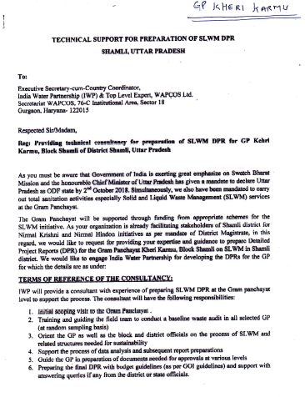

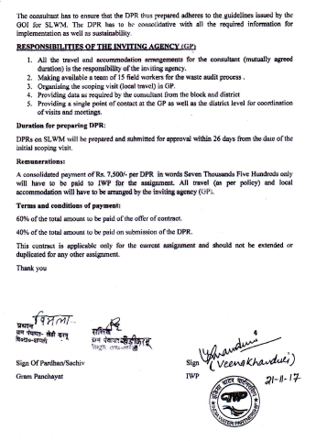

Annexure 2: Methodologies followed for preparing the DPR

To understand the existing condition of the village and to assess the solid and liquid waste systems and further to provide recommendations the following activities were carried out:
- Initial Orientation Workshop
- Transact Walk/ reconnaissance Survey
- Discussions with Key Stakeholders/ Gram panchayat officials
- Participatory Rural Appraisal (PRA) and Village Mapping
- DPR Discussion with the Key Stakeholders for their Comments and Suggestions
- Final Discussion of DPR in Gram Sabha

Orientation Workshop

The team visited Shamli Block in Muzzaffarnagar district. The workshop was kicked-off by Block Development Officer (BDO) in presence of Pradahan, PanchayatSamiti. The BDO introduced the consultant team to various stakeholders; comprising Sarpanches, Ex-Sarpanches, Anganwadi workers, and local NGO, and villagers. The future plans and objectives related to Solid Liquid Waste Management (SLWM) were discussed during the workshop. The officials and other participants showed keenness to provide timely and active support in developing and executing SLWM activities in their respective GPs.

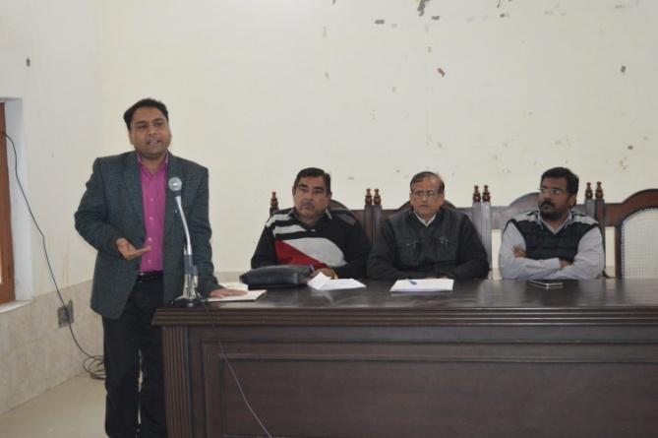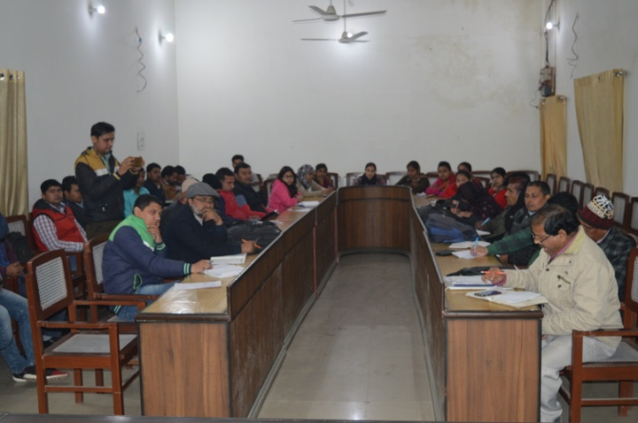
Orientation Workshop

The representatives from various GPs highlighted problems and challenges which are faced at the grass root level in sanitation sector. These are:
- Garbage pits are not present in the villages due to which is thrown along the roads, in the drains or at vacant place
- There are no permanent safai-karamcharis due to which streets and drains are not cleaned regularly. Presently, to clean the drains and villages, Gram Panchayat hires few workers three to four times in a year.
- Animal waste and vegetable waste is either dumped within the house premises or just outside the house which is alter on used as manure for the fields, but other waste such as plastic, paper, cloth etc. is either thrown at open areas or burnt.
- Waste water is not a big problem for villages at foothill, as water drains out of the village due to the slope. But, in plain areas either waste water gets accumulated on streets, open land or local pond.
- Blockage of drains also leads to overflowing of waste water onto streets.
After understanding the issues from the stakeholders, Pradhan and BDO suggested that behavioural change is needed for successful implementation of the project which can be brought in by spreading awareness amongst all the villagers by informing the benefits of SLWM.The workshop was closed with the selection of potential Gram Panchayats for pilot cases based on the discussions with officials and the selection criteria such as ODF/ NGP Status, willingness to support, cluster approach/ individual approach etc. identified by the consultants.

Reconnaissance Survey
Initially, a complete round of the village was undertaken to understand the overall systems, to visit the main thrust areas, and to identify the problem areas.

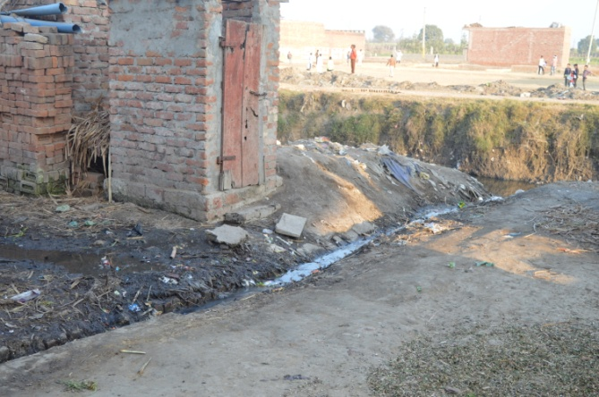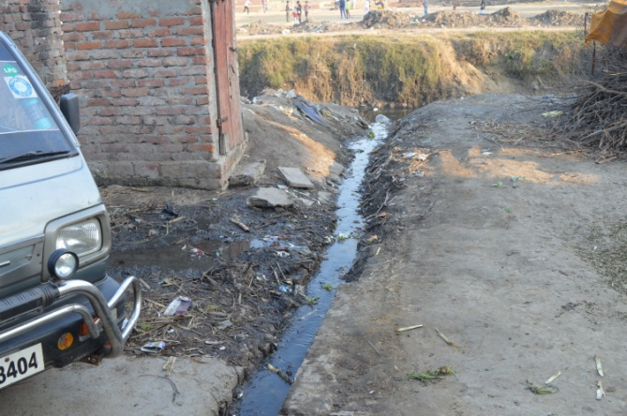

Open Drains and Waste Disposed

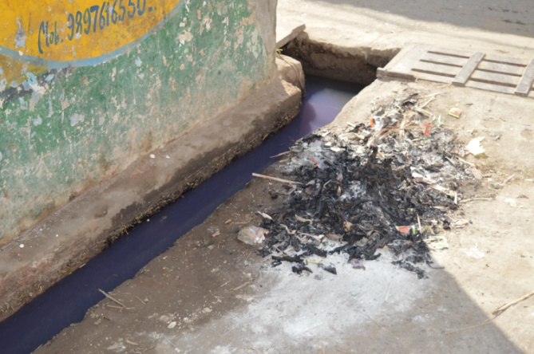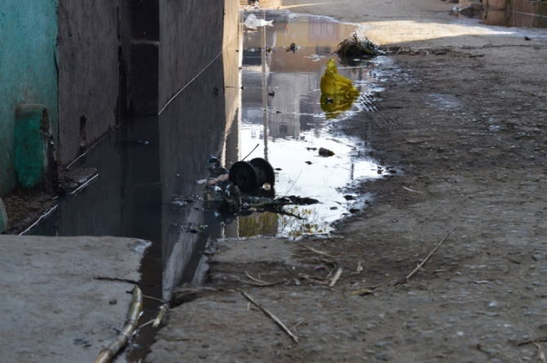
Waste Water on the Roads

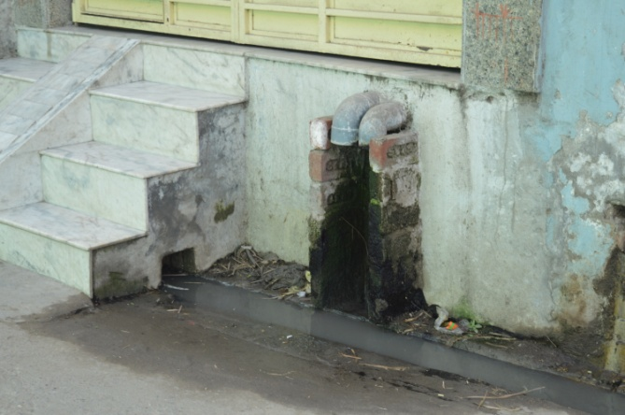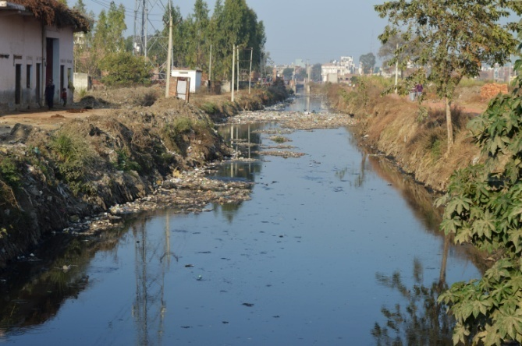
Stream Flowing nearby

Discussions with Key Stakeholders/ Gram panchayat officials
After transact walk, continuous discussions were held with the key stakeholder and Sarpanch, ward members, Gram Sevak etc. of Kheri Karmu GP. The officials and other participants showed keenness to provide timely and active support in developing and executing SLWM activities in their respective GPs.

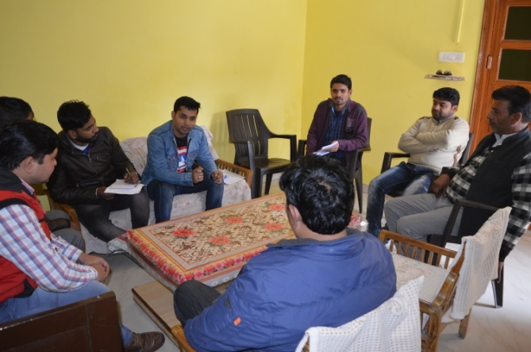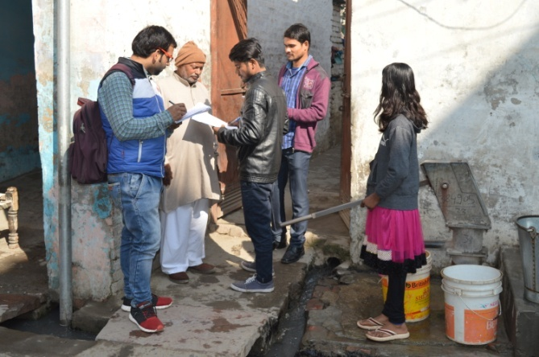
Discusions with the PRI and community members

Participatory Rural Appraisal (PRA) and Village Mapping
The PRA along with the FGDs were conducted at the temple of the Gram panchayats where many stakeholders had gathered to participate in the exercise of village/ resource mapping.

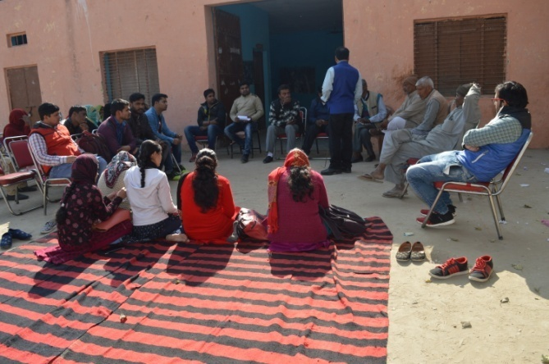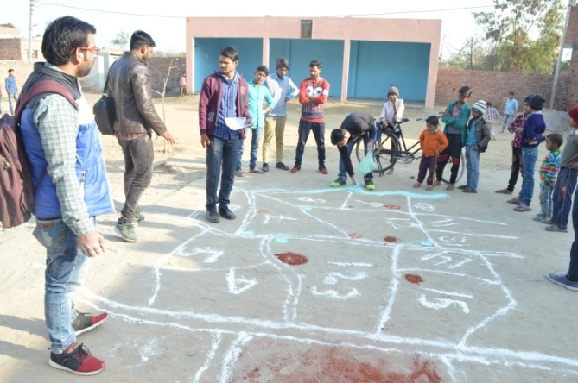
Focused Group Discussions and Resource Mapping in Kheri Karmu Gram Panchayat

DPR Discussion with the Key Stakeholders for their Comments and Suggestions
A workshop was conducted at the Village. Representatives from all the three Gram Panchayats were present in this workshop. The consultant team along with field team shared all the proposals which have been identified in the plan to get suggestions and comments from the local people. Various technical and feasible inputs were received from the local people as well as the funding of the asset creation and its operation and maintenance was discussed. The brief of the discussion and comments and suggestions provided by the villagers has been shown below:

First round of Suggestions and Comments

Sector/ Category | Proposal | Suggestion/ Comment from locals
Solid Waste
Household level segregation | One dustbin at household level (dry waste) | Villagers agreed on the same
House to House Collection | Team suggested to appoint Safai-Karamcharis for collecting waste from the individual households | The villagers suggested that, it would be difficult to follow door-to-door collection as farmers/ workers leave early morning from their homes. So they suggested to keep dustbin (1 – dry waste) for every 10-20 HHs, from where safai-karamcharis can collect and transport the waste
Transportation of waste | Tricycle/ Pick-up with compartments to collect waste from Mohalla level dustbins | Villagers agreed on the same
Cleaning of roads/ drains | Appointment of Safai-Karamcharis for regular cleaning | Villagers agreed on the same
Processing at Dumping of Waste at GP level | A campus is suggested at the specified location which will include a platform for segregation if required, a recovery centre for recyclables, grinder/ crusher for plastics, a hygiene shop etc. | Villagers agreed on the same and suggested few possible sites for the proposed campus
Liquid Waste
Treatment of waste water | Filtration plant at the one outlet of drain and Reed Bed Technology at another outlet. | Villagers agreed on the same
Institutional Set-up
Service Delivery Team | Consultants suggested the formation of a team, wherein a committee would be formed at village level and 4 to 5 safai-karamcharis with a supervisor | Villagers suggested having Ward-wise committee as well under the Gram Panchyat level committee to have proper and regular monitoring.  Also villagers suggested that the Gram Panchayats do not have safai-karamcharis, so they will have to be brought from near-by villages/ Gram Panchayats
Funding
Funds for Asset Creation | Consultants suggested the funds to be procured under SBA funds | Villagers agreed on the same
Funds for Operation and Maintenance | Consultants suggested collection of user fees for day to day operation and salary of the Safai-Karamcharis | Villagers agreed on the same and suggested that extra cost can be shared by Gram Panchayat through SFC/ TFC, untied funds etc.

Final DPR Discussion in Gram Sabha
The Gram Sabha meeting was held to discuss about the plan for Solid and Liquid Resource management and get the views of the villagers.

Highlights from the Gram Sabha
- Issues regarding non treatment of Solid and Liquid waste were discussed in detail.
- The present issues were highlighted with respect to solid and liquid waste and more inputs were taken from the villagers.
- The participants were given an opportunity to suggest ideas to handle the situation which then can be incorporated in the DPR.
- Every aspect of the methodology was explained and consent from the villagers were taken in the form of minutes of the meeting
- Rules and regulations with respect to SLWM to be implemented in the villages were discussed in detail

Final round of Suggestions and Comments

S.No | Discussion points | Decisions taken | Remarks
Solid Resource Management
1. | Source Segregation of garbage – Every household must segregate the garbage in to two categories | 1 dustbin will be distributed to each of the households ONLY ONCE at the start of the project. It is the responsibility of the individuals to ensure that it is maintained.  Panchayat will pass a resolution that each house hold will segregate the waste in the household and deposit the dry waste in the common dustbin and wet waste will be composted. | The service delivery team will report to the SLWM committee about the segregation in the common dustbin. Each dustbin will be numbered and the team will report to the SLWM committee if they find un-segregated garbage in the dustbins.
2 | Placement of Common Dustbins | 1 dustbin will be kept at the corner of each street. On an average each street has about 20 houses. In streets where there are less number of houses they will have to deposit in the dustbin in the adjacent street  Movable type of dustbins is preferred. | The safety of the dustbins will be the responsibility of the households in that particular street. The panchayat will question those households if the dustbins are damaged.
3 | Collection vehicle | It has been decided to use manual cycles for collection of garbage as they are cost effective and easy to maintain/repair or even replace if needed.  Tractors cannot get in to each of the streets and it is also time consuming. | The rickshaws will be made of good quality locally.  3 rickshaws will be purchased.
4 | Service delivery team | A 4 member team will be constituted as the service delivery team. If needed more can be added at a later stage. The Panchayat will take that decision | The 3 member team will be selected by the gram panchayat and their performance will be monitored by the SLWM committee
5 | Resource Recovery centre | This will be located in KhariKarmu village and will be built in 300 sq.ft area. | The maintenance of this centre will be the responsibility of the service delivery team.
Liquid Waste Structures and decisions
3 | Water Treatment | 1 filter beds and 1 reed bed system will be constructed at the two main outlets where 70% of the water gets accumulated.
5 | Maintenance of the structures | The maintenance of the filter beds and the safety of the equipment will be ensured by the SLWM committee | The committee will provide responsibility of maintenance on turn-key basis to the members of the SLWM committee

The gram sabha unanimously decided that the project will be implemented in a swift manner and it will be the responsibility of every individual to ensure that the systems are sustained.

Annexure3: Reed-Bed Technology or Root Zone Technology

Reed bed is natural purifying decentralized waste water treatment. The process was developed in 1970s by Professor Dr. Reinhold Kickuth of Kassel University, Germany.

Reed beds are constructed wetlands (CWs) that are used successfully around the world in thousands of water and wastewater treatment applications. Reed beds can be treated as a natural and inexpensive treatment for domestic, agriculture, industrial, etc. wastes. This effective and sustainable water treatment technology permits the successful management of domestic wastewater, potable treatment sludges, leachate and contaminated groundwater, mining and industrial process water, and winery and agricultural wastewater.

Reed bed technology designs and constructs highly effective and simple to operate systems for treating a wide range of contaminant chemicals including ammonia, BOD, COD, suspended solids, organic chemicals, chlorinated organic chemicals, industrial solvents, and hydrocarbons.

A reed bed is essentially a basin that is lined with sand, gravel and planted with macrophytes such as reeds. Reed bed waste water treatment systems are biological treatment that works by combined action of bacteria and plants. Reed beds rely on biological processing of contaminants to treat water to a quality suitable for environmental disposal or reuse. But unlike activated waste, reed beds consume no energy, require no chemicals, have no moving parts, and are carbon neutral. Reed beds have been operating across Europe and the US for over 20 years to manage and treat domestic wastewater, water treatment waste, leachate and contaminated groundwater, and mining and industrial process water. These systems are still in operation today and continue to function with very little maintenance.

Reeds are rough grasses growing in wet places.Aquatic plant species that can be used as reeds:
- Phragmitesaustralis, Phragmitescommunis, Phragmiteskarka (Also effective in phenol removal)
- Typha spp.(Cattail)
- Schoenoplectusvalidus (Great Bulrush), Schoenopletuslacustris (bulrush)
- Juncusinges (Giant Rush)
- Canna indica
- Stenotaphrumsecundatum

Advantages of Reed-bed Technology
- Zero energy, carbon neutral solutions: Consumes no energy, resulting in reduced greenhouse gas emissions and consequently a reduced carbon footprint.
- Low capital and operation cost: Reedbed Technology also incurs low capital costs and lower operational costs compared to housed mechanical systems.
- No addition of chemicals
- No sludge production
- Highly aesthetic, odourless living and growing systems: Surface reed beds look like a lush garden bed with reeds swaying in the breeze, and they are completely odourless.
- Remove a range of contaminants: Reed beds remove a range of different contaminants including organic loads (BOD), petrochemicals and solvents, suspended solids and sediments, metals, and nutrients.
- Little or no moving parts and on-site treatment of wastewater: Being natural, environmentally sustainable systems, our reed beds have no moving parts and this equates to reduced noise and maintenance, as well as reduced pollution and greenhouse gas emissions compared to mechanical treatment systems.

Reed Bed Filter System

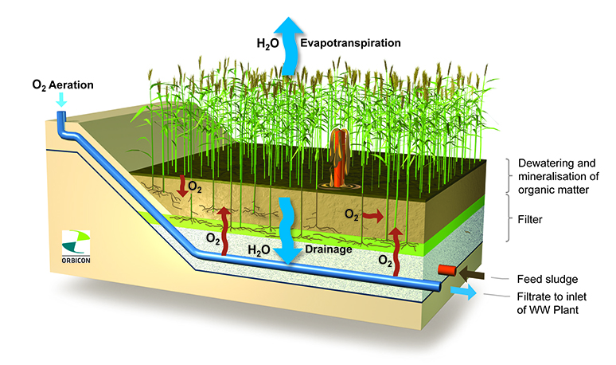

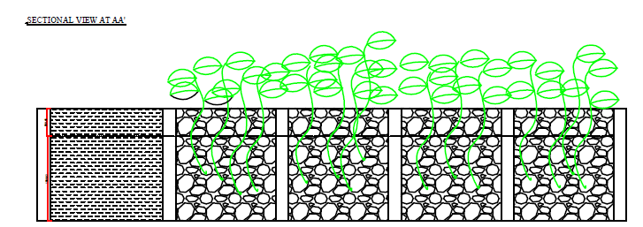

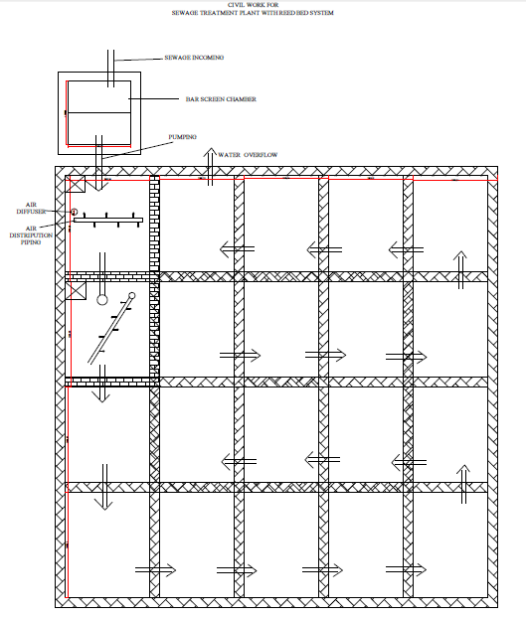

Schematic Diagram of Filter Bed
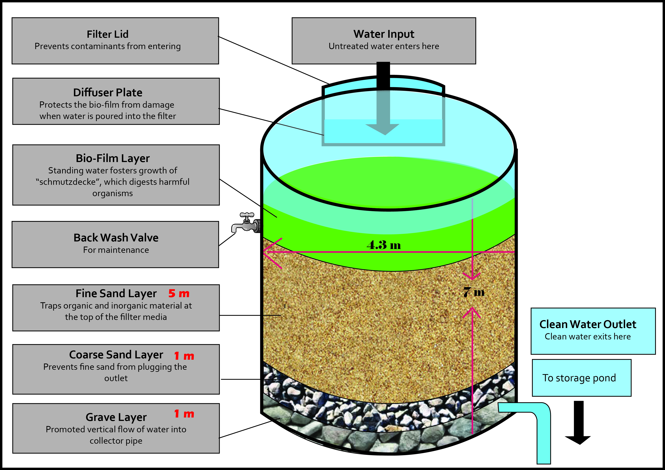

Annexure 4: Financial Details of Reed-Bed Filter

QUOTATION FOR SEWAGE TREATMENT PLANT WITH REED BED SYSTEM 100 KLD ( Expandable )

S.NO. | DESCRIPTION | SPECIFICATIONS | QTY. | UNIT | AMOUNT
 | SEWAGE TREATMENT PLANT WITH REED BED FOR { 100KLD ( Expandable ) }
A | MECHANICAL WORK
1 | REED BED FOR PLANTATION | Civil Work | 1 | No. | 510000
 | Designing & Making of Reed Bed | 10Mtr X 10Mtr X 2Mtr Depth
 | Brick Wall
 | PCC
 | Plasting
 | Connecting Piping
 | Wall Painting
 | Filling of Reed Bed with Stone Pallets / Big Rori
 | Plantation
2 | HYPO DOSING SYSTEM | PVC Hypo Dosing Tank 200 ltrs. . & Pump 0-6Ltrs. | 1 | SET | 10000
3 | G.I. / PVC PIPING & FITTING & BUTTER FLY BALL VALVES |  | 1 | LOT | 30000
4 | ELECTRICAL PENEL WITH ENERGY METER | Bentex / Siemens /Ventilair | 1 | NO. | 35000
B | ELECTRICAL WORK
1 | SEWAGE TRANSFER PUMP SET- 1.5HP ( 1W +1S ) | Crompton Greaves / Kirlosker | 2 | Nos. | 30000
C | CHEMICALS FOR STP
1 | EM SOLUTION ( BIO CULTURE) | Effective Micro Bio Organisam | 100 | Ltrs. | 20000
2 | HYPO SOLUTIONS |  | 100 | Ltrs. | 10000
D | INSTALLATION |  | 1 | NO. | 50000
 |  |  |  |  | 695000
 | Packing & Forwarding @ 2% |  |  |  | 13900
 |  |  |  |  | 708900
 | GST @ 18% or as per applicable |  |  |  | 127602
 | TOTAL |  |  |  | 836502
(RUPEES Eight Lakhs Thirty Six Thousand Five Hundred Two ONLY)
( 100KLD ) AREA REQUIRED FOR REED BED = 100 squre mtrs

Either Community or Households dustbins will be distributed.

